**AAE6102 Assignment**

Assignment report

XU Haosheng

## Question:

Let’s take a look of the single-epoch data sets rcvr.dat and eph.dat in the attached folder to

set up the linearized navigation equations and solve for user position and clock bias. These

equations can be solved iteratively as described in class. The required corrections for the

satellite clock bias and relativity are detailed in the ICD attached. We will skip the

ionospheric corrections because we do not have access to the parameter values of the

Klobuchar model for this data set. Tropospheric correction based on standard atmosphere

model is optional.

Using (WGS 84 XYZ in meters) as the initial position to begin your iteration. Initial your algorithm with a clock bias of zero. Terminate the iteration

when the change in the estimate is suitably small.

1. What is your estimate of the user clock bias b?
2. Does your estimate of the user clock bias in seconds offer insight as to why the reported receiver clock time at this epoch (Column 1 of the rcvr matrix) is 440992.00173454 seconds? (Hints: Your initial iteration should give (in meters) δx ≈ -5710, δy ≈ 1080, δz ≈ -2610, δb ≈ 519450. Your position estimate (WGS 84 XYZ coordinates, in meters) should be x ≈

## Hints for solution:

Using the data in these two matrices, we can calculate the receiver’s position at the time of week 440992 using the following process.

1. Calculate the XYZ positions for all valid satellites at time 440992.
2. Determine the broadcast satellite clock error.
3. Estimate the tropospheric delay for each satellite (optional).
4. use the linearized GPS measurement equation developed in class to estimate the vector δ*x*ˆ
5. update the estimate of the user position: *X*0 (*new*)= *X*0 (*old*)+δ*x*ˆ
6. if δ*x*ˆ <10−4 m, then we have successfully converged on a valid position solution

## Answer:

Referring to the question, the main algorithm is divided into two parts: **Satellite position** **calculation** and **User position calculation** **by Least squared approach**. The Flowchart of the above algorithm is shown in Fig.1.

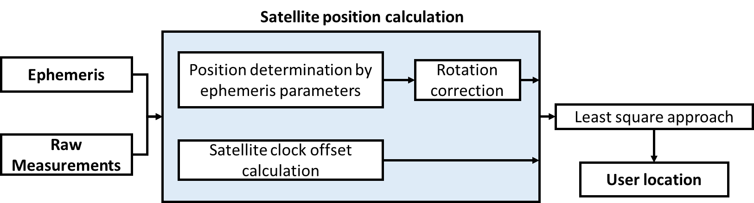

1. Mian flowchart of code

The satellite's position is calculated, then the position of the user is determined by the least square. The steps are arranged as below:

# Calculate the XYZ positions for all valid satellites at time 440992

For the satellite position calculation, there are some elements of ephemeris read from the ‘eph.dat’. The satellite orbit is demonstrated in Fig.2. [1]

1. The demonstration of the orbit. is the inclination of the orbit; is the longitude of the ascending node; is the argument of perigee.

These elements described the orbit of satellites, the detailed calculation is shown below:

The transmission time of satellite signal is calculated by:

where is the receiver local time in the GPS time (seconds), and is the observed range from the measurement, is the speed of light. Then, time from the ephemeris reference epoch is calculated by

where is reference time of ephemeris parameters, if is greater than 302,400 seconds, subtract 604,800 seconds from . If is less than -302,400 seconds, add 604,800 seconds to from IS-GPS-200 [ [2]. The corrected mean motion in rad per sec is calculated by:

where is mean motion correction from the ephemeris and is computed mean motion, which is calculated by

where is WGS 84 value of the earth's gravitational constant for GPS user as 3.986005e14 / , is the semi-major axis from the ephemeris. Mean anomaly is calculated by:

where is mean anomaly at the reference time. Moreover, the mean anomaly could be more accurate by applying Kepler's Equation for Eccentric Anomaly:

where is the eccentricity and the initial value of is the remainder of () from the above equation. The iteration ends with the remainder between and less than 1e-12.

True Anomaly is calculated by

where is the eccentricity and is the eccentric anomaly.

The argument of latitude is calculated by:

where is the argument of perigee. By applying second harmonic perturbations, the corrections are calculated by:

where is the Corrected Argument of latitude; is the Corrected Radius; is Corrected Inclination. The corrected Argument of latitude , radius , and inclinations are calculated by:

where IDOT is the issue of data of ephemeris, is inclination angle at the reference time. The satellite position in the orbital plane is calculated by:

The corrected longitude of ascending node is calculated by:

where is right ascension; is the rate of right ascension; is WGS 84 value of the earth's rotation rate as 7.2921151467 e-5 rad/sec. Finally, the satellite position [] in Earth-fixed coordinates is derived by:

The result of satellites XYZ positions in ECI coordinates is shown in Table 1.

1. The result of satellites XYZ positions in ECI coordinates

|  |  |  |  |
| --- | --- | --- | --- |
| PRN | ECI-X | ECI -Y | ECI -Z |
| 5 | -8855453.1836 | -22060174.2075 | -11922092.5929 |
| 6 | -8087139.4536 | -16946005.6438 | 18816194.5085 |
| 10 | 9027719.3258 | -12319179.5006 | 21737387.5983 |
| 17 | -21277080.2038 | -7467235.4699 | 14287503.4518 |
| 22 | -13649576.6559 | 8229426.9951 | 21122958.5266 |
| 23 | -19452219.4445 | -16750492.2079 | -6918520.6419 |
| 26 | 6163064.1271 | -25286737.1354 | -3541190.2681 |
| 30 | -17713788.1934 | -19797565.2265 | 19209.1324 |

The satellites’ ECI-positions in the geographic map are shown in Fig 3.



1. Satellites’ ECI-positions in the geographic map. The number indicates the pseudo-random noise (PRN) of the satellite

Considering the simple rotation, the ECEF coordinate is calculated by:

where , and the result of satellites XYZ positions in ECEF coordinates is shown in Table 2.

1. The result of satellites XYZ positions in ECEF coordinates

|  |  |  |  |
| --- | --- | --- | --- |
| PRN | ECEF-X | ECEF-Y | ECEF-Z |
| 5 | -8855590.1672 | -22060119.2187 | -11922092.5929 |
| 6 | -8087227.5011 | -16945963.6246 | 18816194.5085 |
| 10 | 9027647.7954 | -12319231.9190 | 21737387.5983 |
| 17 | -21277121.3279 | -7467118.2902 | 14287503.4518 |
| 22 | -13649526.7151 | 8229509.8280 | 21122958.5266 |
| 23 | -19452319.3838 | -16750376.1484 | -6918520.6419 |
| 26 | 6162910.8881 | -25286774.4834 | -3541190.2681 |
| 30 | -17713898.7737 | -19797466.2847 | 19209.1324 |

The satellites’ ECEF-positions in the geographic map are shown in Fig 4.



1. Satellites’ ECEF -positions in the geographic map. The number indicates the pseudo-random noise (PRN) of the satellite

# Determine the broadcast satellite clock error

The code phase offset is given by:

where , and are the polynomial coefficients is the clock data reference time in seconds and is the relativistic correction term (seconds) which is given by

The orbit parameters (e, used here are described in discussions of data contained in subframes, F is a constant as . The code phase offset and satellite clock error are shown in Table 3.

1. The code phase offset and satellite clock error

|  |  |  |
| --- | --- | --- |
| PRN | code phase offset (s) | satellite clock error (m) |
| 5 | 1.8907E-04 | 56680.48 |
| 6 | -8.3932E-08 | -25.1623 |
| 10 | 3.3248E-05 | 9967.388 |
| 17 | -2.0490E-04 | -61428.3 |
| 22 | 2.2268E-04 | 66757.21 |
| 23 | 1.0360E-05 | 3105.913 |
| 26 | 2.8099E-04 | 84239.63 |
| 30 | -1.0041E-05 | -3010.26 |

# Estimate the tropospheric delay for each satellite

Since there is no precise received date and tropospheric parameter from the nearby reference station. For the tropospheric delay, the Saastamoinen Model [3] is applied to our applications, which is expressed as:

where is the surface atmospheric pressure in mbar, is the surface temperature in Kelvin, is the surface partial pressure of water vapor in mbar. Based on the satellite's position and initial user location, the tropospheric delay for each satellite is shown in Table 4.

1. The tropospheric delay for each satellite

|  |  |
| --- | --- |
| PRN | tropospheric delay (m) |
| 5 | 11.653 |
| 6 | 2.464 |
| 10 | 4.846 |
| 17 | 3.180 |
| 22 | 8.513 |
| 23 | 6.329 |
| 26 | 9.660 |
| 30 | 3.659 |

# Use the linearized GPS measurement equation developed in class to estimate user location

For localization, the least square approach is applied. The linearized GNSS pseudo-range observation equation is expressed by:

𝜌= 𝐻 + 𝜖

where 𝜌 is the difference between the measured and predicted pseudoranges; 𝐻 is the geometry matrix; ∆𝑋 is the error state vector between the user state (𝑥, 𝑦, 𝑧, 𝛿𝑡) and an initial guess ; According to the question, the initial guess is set as , and the first iteration difference is set as . The geometry of satellites is shown in Fig 5.

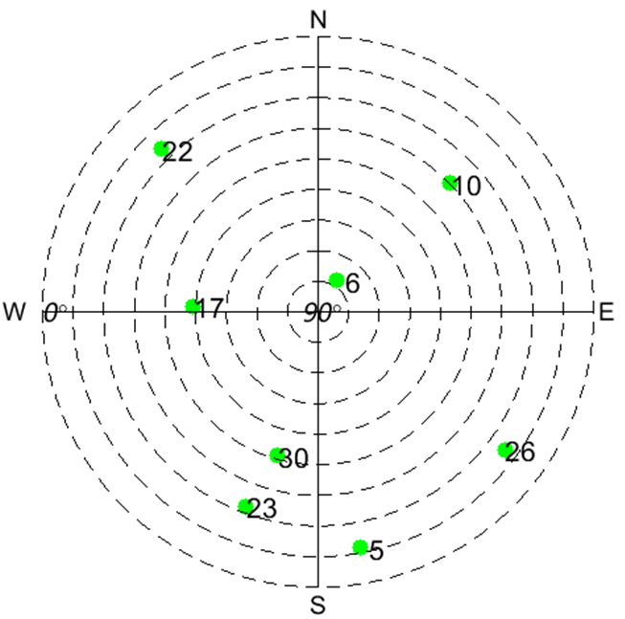

1. The geometry of satellites. The number indicates the pseudo-random noise (PRN) of the satellite

The raw pseudorange is cleaned by combining the satellite clock error and tropospheric delay, which is expressed by:

where is the corrected pseudorange, and is speed of light. The residual of each iteration in position domain is calculated by:

The estimated location for each step of Least squared is shown in Table 5.

1. The estimated location for each step of Least squared

|  |  |  |  |  |
| --- | --- | --- | --- | --- |
| Step | ECEF-X (m) | ECEF-Y (m) | ECEF-Z (m) | (m) |
| 0 | -2694685.473 | -4293642.366 | 3857878.924 | 0 |
| 1 | -2700420.267 | -4292537.554 | 3855266.014 | 6.39811E+03 |
| 2 | -2700420.399 | -4292537.654 | 3855266.119 | 1.95321E-01 |
| 3 | -2700420.399 | -4292537.654 | 3855266.119 | 6.72172E-08 |

The position for the first and final iteration is shown in the Fig 6.

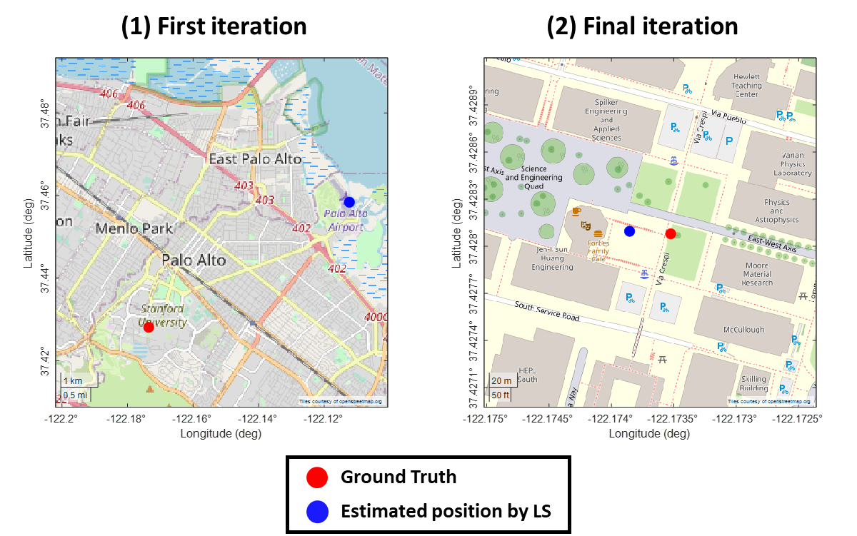

1. The position for the first and final iteration. The ground truth is the position given by the assignment.

The user clock bias b for each step is shown in the Table 6.

1. The user clock bias b in range and time domain.

|  |  |  |
| --- | --- | --- |
| Step | (m) | (second) |
| 0 | 0 | 0 |
| 1 | 5.194503E+05 | 1.732700E-03 |
| 2 | 5.194497E+05 | 1.732698E-03 |

Question: What is your estimate of the user clock bias b?

The user clock bias is 5.194497E+05 meter or 0.001732698 second.

Question: Does your estimate of the user clock bias in seconds offer insight as to why the reported receiver clock time at this epoch (Column 1 of the rcvr matrix) is 440992.00173454.

We use the epoch of 440992 as the receiver local time in the positioning, which added the bias for every satellites. So, after applying the least square approach, the estimated user clock bias is 0.001732698 second, which is near to the 0.00173454 from the rcvr file.

Question: what is the GitHub experiment?

The GitHub link is <https://github.com/HsXu2Mimo/AAE6102-Assignment>

## Reference:

[1] E. D. K. C. J. Hegarty, *Understanding GPS Principles and Application*. Artech house, 2005.

[2] N. the National Coordination Office for Space-Based Positioning, and Timing. "Interface Control Documents of the GPS program." the National Coordination Office for Space-Based Positioning, Navigation, and Timing. (accessed 28.oct, 2021).

[3] J. Saastamoinen, "Contributions to the theory of atmospheric refraction," *Bulletin Géodésique (1946-1975),* vol. 105, no. 1, pp. 279-298, 1972/09/01 1972, doi: 10.1007/BF02521844.